The objective of the lab experiment was to introduce the basics of AWS Identity and Access Management (IAM) service and understand how to create and manage IAM users and groups. Through the experiment, I was able to gain a better understanding of the fundamentals of IAM and its components, including users, groups, policies, and roles.

I was also able to get a hands-on experience of creating and managing IAM users, groups, and policies. This gave me an opportunity to apply the concepts that I had learned to the practical aspects of IAM. I was able to understand the process of creating a user, assigning a group to the user, and defining the permissions of the user. I also learned how to create a group and assign a policy to that group.

Overall, the experiment was a great learning experience for me. It provided me with the theoretical and practical knowledge of IAM service and its components. I was able to understand the concepts in deeper detail and was able to apply them to the real-life scenarios.

The lab began by creating an IAM user and assigning policies to the user. It then went on to discuss how to create a group and add IAM users to the group. After that, the lab demonstrated how to create a policy and attach it to the group. Finally, the lab showed how to use the AWS CLI to access AWS resources with IAM credentials. The procedure was well-documented and easy to follow, and it included screenshots for each step to help guide the user. Overall, the lab provided an easy-to-follow guide to setting up IAM credentials and accessing AWS resources.

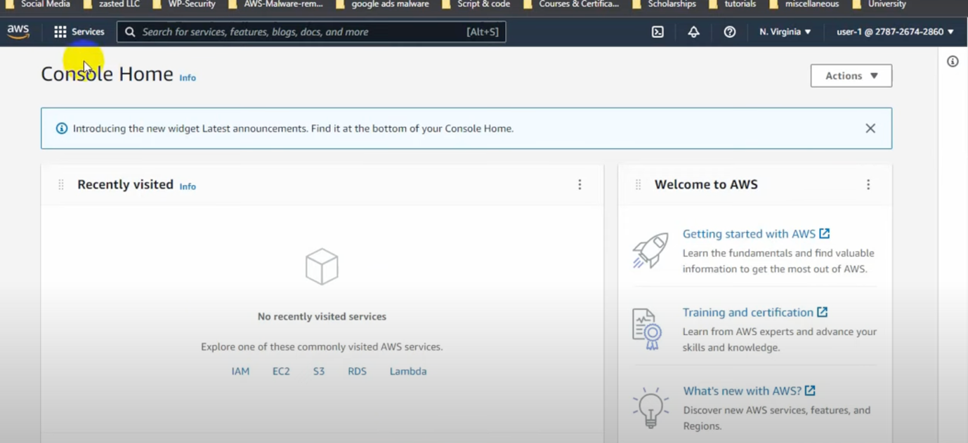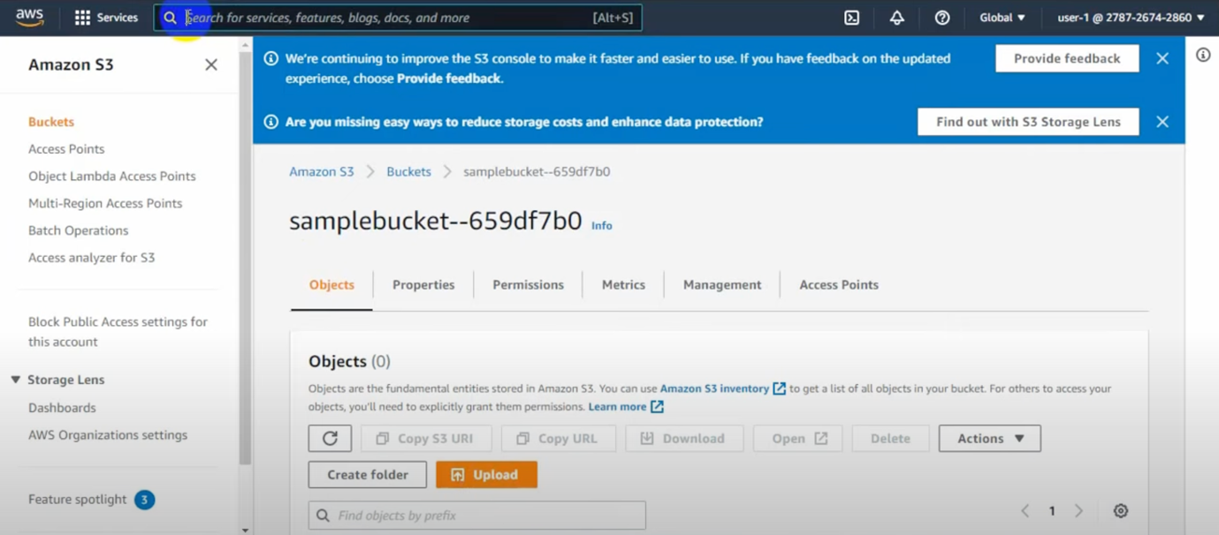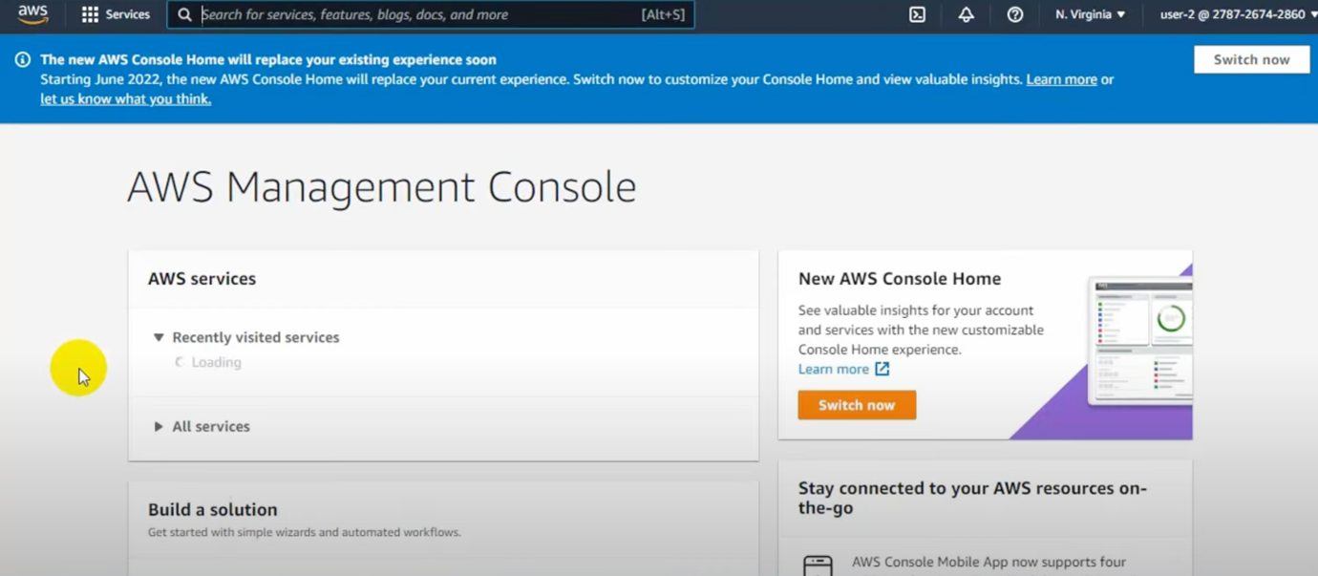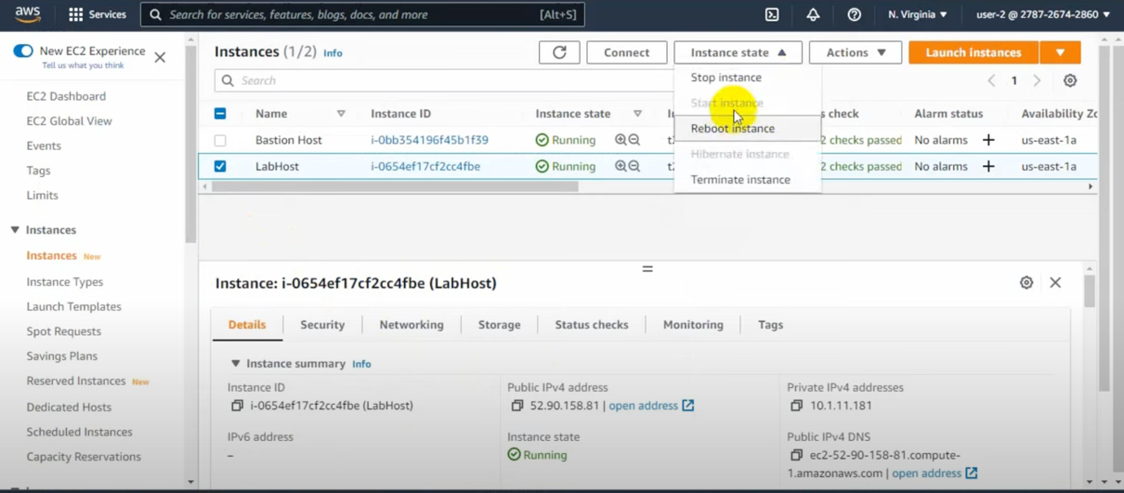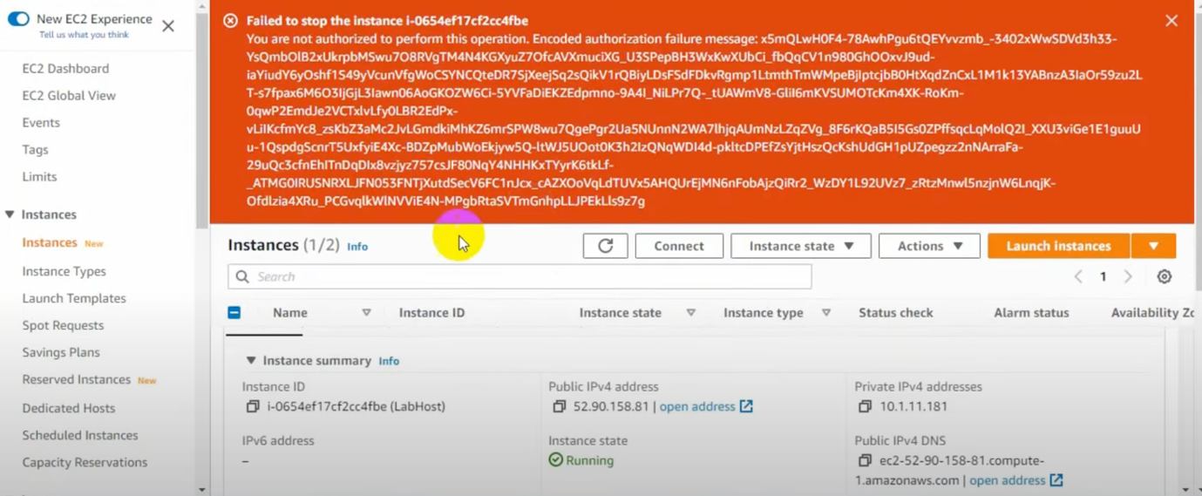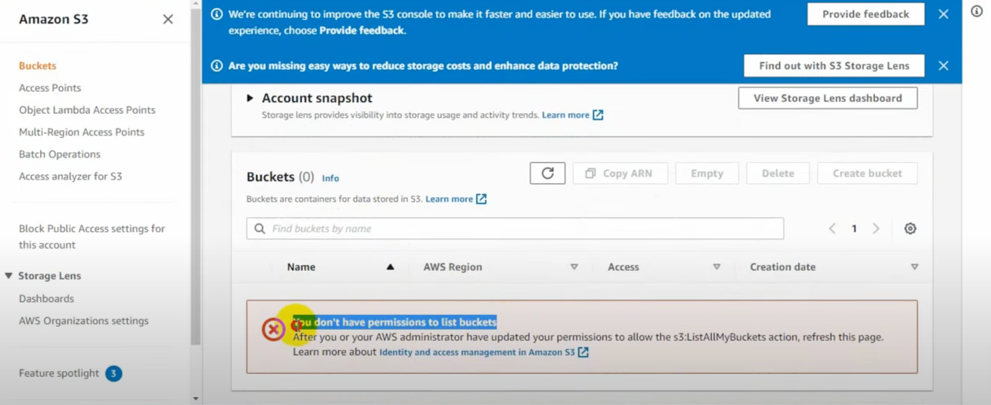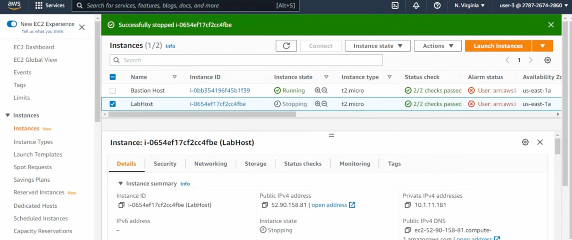

IAM policies are a critical part of granting and restricting access to AWS resources. Learning about IAM policies and how to create and attach them to users and groups was an invaluable part of my activity. I was able to gain an understanding of who can access what resources, and how I can set up user permissions to ensure that the right users have the right access. The knowledge I gained in this part of the activity was extremely useful and enabled me to understand how to grant or restrict access to specific AWS resources based on the user's permissions. This part of the activity was critical in helping me develop a deeper understanding of IAM policies and how to manage user access.

This lab was surprisingly straightforward. I didn't encounter any significant difficulties, though I did find some sections somewhat challenging, such as creating roles and defining trust policies. However, the instructions and screenshots provided were invaluable in overcoming these challenges. I was able to complete all the sections without any incompleteness, which I found to be quite satisfying. My understanding of AWS IAM and its capabilities was greatly improved by working through the lab. Overall, I am pleased with the results of my efforts.